Lab 8 Write-up

OneCard:

# Mini-Research Question

In the paper “Structure and function of the global ocean microbiome,” Sunagawa et al. found that overall variability in a community (as measured by principle component analysis) was best explained by temperate. (Sunagawa et al., 2015)

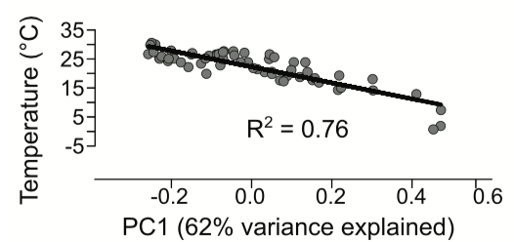

Item . The Figure 5a from the Sunagawa et al. paper.

Thus, one question might be**:** *is there is greater species richness and species diversity (as measured by Shannon-Weiner Index) in warmer water samples (15-30 °C) than in colder water samples (0-10 °C)?*

For analysis, six of the eleven available sample regions were chosen, which span almost the full range of temperatures mentioned in the Sunagawa et al. paper (-0.7 °C – 26.54 °C).

|  |  |  |  |  |  |
| --- | --- | --- | --- | --- | --- |
| Label | Run ID | Region | Sample details | Depth | Temp °C |
| 01\_dcm\_SernOcean | ERR599104 | Southern Ocean (near Antarctica) | deep chlorophyll maximum layer | 90 m | -0.78154 |
| 02\_surface\_SernOcean | ERR599090 | Southern Ocean (near Antarctica) | surface water layer | 5 m | 0.67108 |
| 03\_meso\_SPacific | ERR598999 | South Pacific (near the Marquesas) | mesopelagic zone | 600 m | 7.212238 |
| 04\_surface\_NAtlantic | ERR599078 | North Atlantic (off the coast of Portugal) | surface water layer | 5 m | 14.28065 |
| 05\_dcm\_SPacific | ERR598948 | South Pacific (near the Marquesas) | deep chlorophyll maximum layer | 115 m | 24.69625 |
| 06\_surface\_SPacific | ERR598992 | South Pacific (near the Marquesas) | surface water layer | 5 m | 26.54413 |

Item . Metadata for selected samples. Coloring is to indicate temperature range (cold, medium, warm).

# Data & Analysis

|  |
| --- |
| a.taxonomy_stacked_bar_chart.png |
| b.taxonomy_area_chart.png |

Figure 1. Two different ways-- (a) stacked bar plot, (b) area plot-- of visualizing the taxonomic distribution at taxon level 2, between Tara Ocean Samples, as identified by “Mothur.” These plots were lovingly crafted with Python (using Pandas and Matplotlib.) See: <https://nbviewer.jupyter.org/github/dustinmichels/biol338-genomics/blob/master/lab-8/analysis/dustin_matplot_charts.ipynb> .

Figure 2

Table . A table

|  |  |  |  |  |
| --- | --- | --- | --- | --- |
| Sample:  Label | Sample:  Run Id | Total Number Sequences | Species Richness (r) | Shannon-Weiner index (H’) |
| 01\_dcm\_SernOcean | ERR599104 | 8732 | 9 | 1.003610566 |
| 02\_surface\_SernOcean | ERR599090 | 9399 | 5 | 0.974619646 |
| 03\_meso\_SPacific | ERR598999 | 9539 | 20 | 1.714318417 |
| 04\_surface\_NAtlantic | ERR599078 | 9551 | 15 | 1.544702156 |
| 05\_dcm\_SPacific | ERR598948 | 9588 | 17 | 1.349562238 |
| 06\_surface\_SPacific | ERR598992 | 9706 | 13 | 1.513954316 |

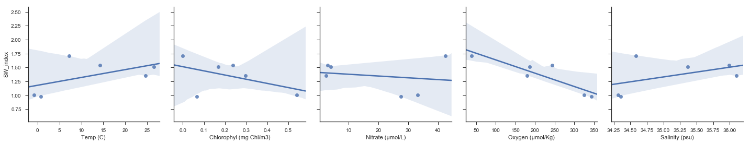

Figure 2. Another attempt at generating plots programmatically with Python/Jupyter/Matplotlib, this time to show a scatter plot of each of five metadata attributes vs. the Shannon-Weiner Index. This script wasn’t quite as successful as the last one. The regression lines are drawn by I can't figure out how to display the R2 values.

# Check for Understanding

**1. Many of your sequences were unclassifiable. How would this likely affect your richness calculations for each sample? Explain why.**

Some text.

**2. What is the difference between richness and the Shannon-Weiner index? Describe a situation in which you might have a high richness but a relatively low Shannon-Weiner index.**

Some text.

**3. Does your taxonomic diversity, as calculated by the Shannon-Weiner index, correlate with any of the metadata for your sample (temperature, chlorophyll, nitrate, oxygen, salinity)? (The R squared value should vary between 0 and 1; the stronger the correlation, the closer the R-squared value is to 1. We did not calculate p-values or conduct a more rigorous statistical analysis, but the R-squared value will tell you how closely the variables are correlated.) Write a short paragraph speculating on any correlations you find. (It's possible the correlations will be terrible.)**

Some text.

# Mini-Research Conclusion